# LTspice Voltage Divider Lab

Seth Ricks

9/19/2025

ECEN 350 - Brother Swenson

# ECEN 350 Lab – LTspice Voltage Divider Lab (50 points)

(jas, LTspice Voltage Divider Lab.docx, 8/30/2025)

**Purpose:** The purpose of this lab is to demonstrate some applications of voltage dividers and to increase your understanding of the design and workings of Digital Multimeters (DMMs).

**Solving Systems of Linear Equations Using Matrices.**

The following discussion details the matrix method of solving a system of linear equations, to be used later in this lab. Only a minimal understanding of matrix algebra is needed to use matrices in MATLAB to solve simultaneous equations.

Using MATLAB and matrices to solve the following two linear equations with two unknowns will be demonstrated.

x1 + x2 = 17. (Eq. 1)

4x1 + 2x2 = 40. (Eq. 2)

The above equations can be viewed in terms of coefficients as follows:

(1)x1 + (1)x2 = 17.

(4)x1 + (2)x2 = 40.

A matrix is a mathematical object consisting of an arrangement of elements into rows and columns. For example, the following matrix **A** represents the coefficients of the unknowns x1 and x2 for **Equation 1** and **2**:

$$A=\left[\begin{matrix}1 & 1 \\ 4 & 2\end{matrix}\right].$$

In MATLAB, a vector is a matrix with only one row or one column. A vector with one row and many columns is referred to as a row vector, whereas a vector with one column and many rows is considered a column vector. From **Equation 1** and **2**, the unknown variables x1 and x2, along with the coefficients 17 and 40 can be represented as the column vectors **x** and **b** as given below.

$$x=\left[\begin{aligned}x1 \\ x2\end{aligned}\right]. b=\left[\begin{aligned}17 \\ 40\end{aligned}\right]$$

In Matrix form, **Equation 1** and **2** are represented as follows:

$$\left[\begin{matrix}1 & 1 \\ 4 & 2\end{matrix}\right]\left[\begin{aligned}x1 \\ x2\end{aligned}\right]=\left[\begin{aligned}17 \\ 40\end{aligned}\right] or equivalently as Ax=b$$

where the bold characters indicate matrices or vectors and $\left[\begin{matrix}1 & 1 \\ 4 & 2\end{matrix}\right]\left[\begin{aligned}x1 \\ x2\end{aligned}\right]$ represent matrix multiplication of matrix **A** by vector **x**. Matrix multiplication is performed row by column and results in the expansion of the above matrix form back to the original form of **Equation 1** and **2**. Matrices offer a convenient way to represent systems of equations while also providing a powerful way for solving for the unknowns. Using matrix form, the unknown vector $x=\left[\begin{aligned}x1 \\ x2\end{aligned}\right]$ values are solved by evaluating the expression **x** = **A-1b**, where **A-1** refers to as the inverse matrix. While the details of how to determine the inverse matrix are beyond the scope of this lab, MATLAB performs this operation without users needing to understand the details. Users only need to construct and enter the appropriate **A** matrix and **b** vector into MATLAB and invoke the expression x = A^-1*b to solve systems of linear equations. The previously mentioned **A** matrix and **b** vector are entered into the MATLAB as follows: (Note: MATLAB does not utilize bolded characters for matrices or vectors.)

A = [1, 1; 4, 2];

b = [17; 40];

In MATLAB, square brackets [ ] indicate that the enclosed values constitute a matrix, array or vector, whereas the semicolon ; has two different functions in the above expressions. In a matrix, array or vector, a semicolon ; tells MATLAB to start a new row. Whereas a semicolon ; appearing at the end of an expression tells MATLAB to suppress the resulting output from that expression in the Command Window. **Figure 1** below illustrates using the MATLAB Command Window along with matrix algebra to solve **Equation 1** and **2** from above.

**Figure 1:** MATLAB Command Window Example for Solving **x** = **A-1b**.

Referring to **Figure 1**, the Command Window prompt >> indicates MATLAB is waiting for user input. Entering the expression x = A^-1*b without a semicolon at the end in the Command Window results in MATLAB solving for x = A^-1*b and then displaying the solution. In the example of **Figure 1**, the solution is contained in the 2-element vector x corresponding to x1 and x2 from **Equation 1** and **2**. The solution vector can be any reasonable variable name besides x, such as v for voltages as used in the next example. The inverse matrix approach to solving systems of linear equations is a widely used approach that can be expanded to matrix dimensions much larger than 2 x 2.

**Procedure:**

**Part 1 – Voltage Dividers**

Voltage dividers are series circuits used to provide scaled down voltages with the scale factor determined by a ratio of resistor values. The voltage drop across any individual resistor $R_{n}$ in a series circuit with N series resistors can be calculated as follows using the General Case Voltage Divider formula:

For example, in the adjacent circuit with seven series resistors, N = 7 and the voltage drop across resistor R3 is determined as follows:

**Figure 2:** Voltage Divider Circuit Consisting of 7 Series Resistors.

$$V_{R3}=\text{V}\text{in}\frac{R3}{R1+R2+R3+R4+R5+R6+R7}.$$

The voltage drop $V_{R3}$ calculated above for the circuit of **Figure 2** is a fractional part of the applied voltage $V_{in}$, with the fractional part simply equal to the ratio of resistance R3 with respect to the total resistance.

1. Diagram, schematic

   Description automatically generatedFor the adjacent Voltage Divider Circuit, calculate the value of resistor R2 necessary to achieve 5 V at Vout. Be sure to include units with your answer and verify that your calculated R2 value results in Vout = 5 V.

**Figure 3:** Two Resistor Voltage Divider Circuit.

R2 = 0.2 MΩ (2 points.)

Check: (0.2 MΩ / 2MΩ) * 50 = 5V

**Part 2 – DMM Voltage Measurements**

**Digital Multimeters**

A Digital Multimeter (DMM) is a useful piece of test equipment capable of measuring a multitude of quantities including both AC and DC voltage and current, along with DC resistance. The relatively inexpensive (<$40) Velleman DVM890F Portable DMM is illustrated below in **Figure 4**.

**Figure 4**: Velleman DVM890F Portable DMM.

Inexpensive DMMs, like the one illustrated in **Figure 4**, provide good quality measurements for both large and small voltages by providing multiple measurement ranges. The DMM illustrated in **Figure 4** provides DC voltage measurement ranges of 200 mV, 2.0 V, 20 V, 200 V and 1000 V. It should be noted that each of the DC voltage measurement ranges can measure both positive and negative voltages, meaning that the 200 mV input range has a full-scale input range of ±200 mV.

The five different DC voltage measurement ranges of the DMM circuitry illustrated in **Figure 5** is achieved by means of a resistive voltage divider placed between the VΩHz and COM (Common) input terminals. The rotary switch on the front of the meter determines which node from the voltage divider gets measured by the internal Analog-to-Digital Converter (ADC). The ADC illustrated in **Figure 5** requires very little current from the voltage divider, resulting in resistors R1 through R5 having essentially the same current flowing through them, which is a necessary condition for the voltage divider equation. The N200mV, N2.0V, N20V, N200V and N1000V nodes of the voltage divider illustrated in **Figure 5**, correspond to the 200 mV, 2.0 V, 20 V, 200 V and 1000 V DC input voltage ranges, respectively.

**Figure 5:** Typical Portable Digital Multi-Meter (DMM) Voltage Measurement Section.

As illustrated in **Figure 5**, the ADC has a full-scale measurement range of only ±200 mV, corresponding to the smallest DC input voltage range offered. Setting the rotary dial to the N200mV position corresponds to the 200 mV input voltage range and connects the voltage appearing across the VΩHz and COM (Common) input terminals to the ADC input without any voltage division. To enable the DMM to measure input voltages larger than 200 mV, voltage division is used. The voltages at the nodes N2.0V, N20V, N200V and N1000V in **Figure 5** are all divided down version of the voltages applied across the VΩHz and COM (Common) input terminals, and all equal 200 mV for the corresponding full-scale input. For example, when a DC voltage of 1000 V is connected across the VΩHz and COM (Common) terminals of the **Figure 5** circuitry, the divide down voltage appearing at the N1000V node of the voltage divider equals 200 mV. A 200 mV measurement by the ADC for the rotary switch set to the 1000 V dc input range produces a displayed reading of 1000 V by the DMM.

A very large total resistance between the VΩHz input and COM (Common) input terminals is desirable so that negligible input current flows into the DMM when performing voltage measurements. Most DMMs use voltage dividers having a total resistance of 10 MΩ between the VΩHz input and COM (Common) terminals. Hence, in the DMM circuitry of **Figure 5**, R1 + R2 + R3 + R4 + R5 = 10 MΩ. Knowing the necessary node voltages for the each of the full-scale voltage ranges, along with the total resistance of the voltage divider is sufficient information to solve for the necessary voltage divider resistor values, which is the main objective of this lab. To solve for five unknown resistor values, five independent equations are needed and then solved simultaneously.

**Custom DMM Voltage Measurement Ranges**

A DMM Voltage Measurement Section with different input voltage ranges than those of the **Figure 5** circuitry is shown below in **Figure 6**. You are to solve for the necessary resistor values to provide DC voltage measurement ranges of 250 mV, 5.0 V, 50 V, 250 V and 1000 V. The DMM illustrated in **Figure 6** is also to have an input impedance equal to 10 MΩ, meaning that R1 + R2 + R3 + R4 + R5 = 10 MΩ, which is one of the five independent equations needed to solve for R1 through R5.

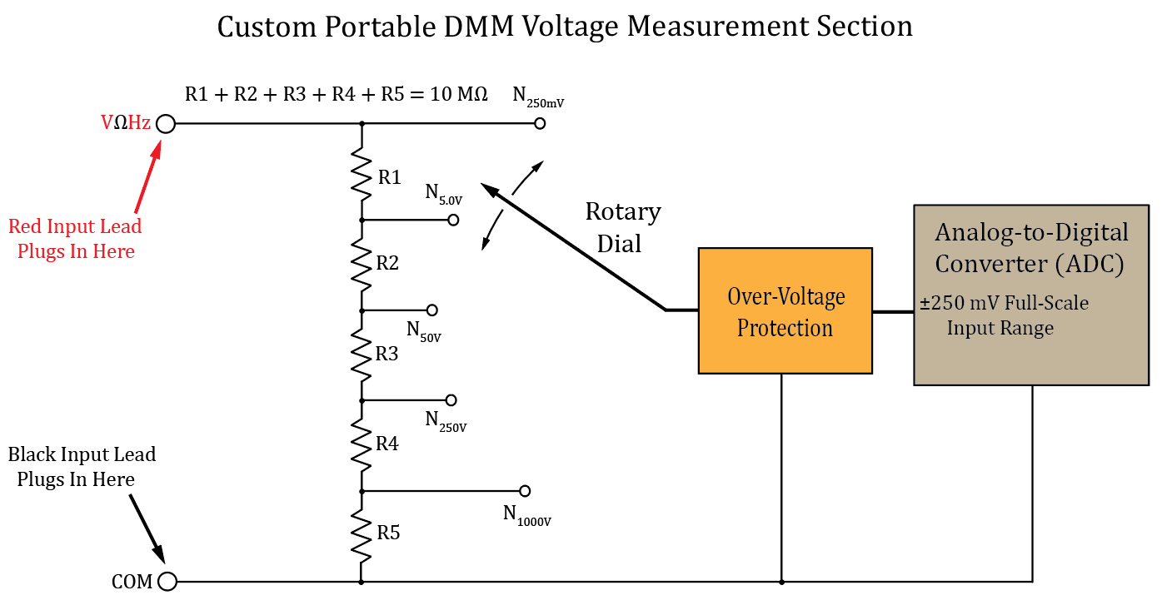

**Figure 6:** Custom Portable Digital Multi-Meter (DMM) Voltage Measurement Section.

The remaining four equations required to solve for the R1 through R5 resistor values in **Figure 6** can be derived by applying the voltage divider equation for the node voltages N5.0V, N50V, N250V and N1000V. Since the ADC in **Figure 6** has a 250 mV maximum measurement voltage range, the divided down voltages at the nodes N5.0V, N50V, N250V and N1000V in **Figure 6** must all equal 250 mV when the corresponding full-scale input is applied across the VΩHz and COM (Common) input terminals.

The resulting five equations can be expressed in matrix form and then simultaneously solved for the resistance values of R1 through R5 as follows:

$$Ax=b, \left[\begin{aligned}1, 1, 1, 1, 1 \\ ?, ?, ?, ?, ? \\ ?, ?, ?, ?, ? \\ ?, ?, ?, ?, ? \\ ?, ?, ?, ?, ?\end{aligned}\right]\left[\begin{aligned}R1 \\ R2 \\ R3 \\ R4 \\ R5\end{aligned}\right]=\left[\begin{aligned}b1 \\ b2 \\ b3 \\ b4 \\ b5\end{aligned}\right]. x=A^{-1}b.$$

In the above matrix equation, the first row of the coefficient matrix A is multiplied by the column vector of resistors R1 through R5 and set equal to b1, resulting in the following equation when expanded out, corresponding to the N250mV node:

$$\left(1\right)R1+\left(1\right)R2+\left(1\right)R3+\left(1\right)R4+\left(1\right)R5=b1=10 MΩ.$$

Accordingly, the second row of the above matrix equation **Ax** = **b**, corresponds to the equation derived from the node N5.0V with the full-scale voltage of 5.0 V applied across the VΩHz and COM (Common) input terminals. In a like manner, the equations for node voltages N50V, N250V and N1000V in **Figure 6**, correspond to the 3rd, 4th, and 5th rows, respectively, of the above matrix equation. (Note: The node voltages N5.0V, N50V, N250V and N1000V should each equal 250 mV when the corresponding full-scale input voltage is applied to the VΩHz and COM inputs.) For example, for the N50V node of the voltage divider in **Figure 6**, Vin = 50 V, $V_{out}=N_{50V}=250 mV= V\text{in_full-scale}\frac{R_{b}}{R_{Total}}$, with Rb = R3 + R4 + R5, and RTotal = . This equation can be rearranged in terms of coefficients for the **A** matrix as follows:

$$\left(0\right)R1+\left(0\right)R2+\left(1\right)R3+\left(1\right)R4+\left(1\right)R5=b_{3}, , where b_{3}=\frac{N_{50V}R_{Total}}{V\text{in_full-scale}}.$$

1. Derive the four other equations, i.e., the equations for the nodes N5.0V, N50V, N250V and N1000V, illustrated in **Figure 6**. Solve for numeric values and include units for your numeric b terms with the b terms having units of Ω. Do not include units for the unknowns R1 – R5 in your following equations. (8 points, 2 points per equation.)
$$\left(0\right)R1+\left(1\right)R2+\left(1\right)R3+\left(1\right)R4+\left(1\right)R5=b2=500,000Ω$$

$$\left(0\right)R1+\left(0\right)R2+\left(1\right)R3+\left(1\right)R4+\left(1\right)R5=b2=50,000Ω$$

$$\left(0\right)R1+\left(0\right)R2+\left(0\right)R3+\left(1\right)R4+\left(1\right)R5=b2=10,000Ω$$

$$\left(0\right)R1+\left(0\right)R2+\left(0\right)R3+\left(0\right)R4+\left(1\right)R5=b2=2,500Ω$$

2. Next form the matrix equation **Ax** = **b** with your four additional equations in terms of resistors R1 through R5, then solve for the R1 through R5 values needed for the voltage divider by means of **x** = **A-1b** using MATLAB or some other method. (Note: All resistor values should be positive with R1 + R2 + R3 + R4 + R5 = 10 MΩ.)

Check:

1. Then construct an LTspice circuit of your voltage divider, including your calculated resistance values along with node names for the voltage divider range nodes. Place net names on each voltage divider range nodes using the Net Name icon  on the top toolbar, labeling each net according to the names given in **Figure 6**. In the Net Name pane, select **Port Type** as **Output**, then place each port onto wire segments protruding from the voltage divider string as illustrated in **Figure 7** below. In the **Edit** pull-down menu, add your name to your schematic as follows: **Edit 🡪 Aa Text**. Replace the schematic shown in **Figure 7** below with your version, including your calculated resistor values and your name. (11 points.)

**Figure 7:** LTspice Voltage Divider Schematic.

1. Using operating point (.**op**) analysis in LTspice, verify proper operation of your voltage divider by completing **Table 1** below for Vin = 250 mV, 5.0 V, 50 V, 250 V and 1000 V. Be sure to include units with your simulated values, as the column headings are node names and not indicative of the units corresponding to that column of data. For each input voltage, the corresponding range output should have a node voltage equal to 250 mV. For example, for a 50 V input, the node N50V should have a node voltage of 250 mV. (Note: Leave out the spaces when entering component values into LTspice, as space characters are not recognized. For example, enter 1kohm for a value of 1 kΩ.)

(10 points.)

**Table 1: Simulated Voltage Divider Output Values**

|  |  |  |  |  |  |
| --- | --- | --- | --- | --- | --- |
| **Vin** | **N250mV** | **N5.0V** | **N50V** | **N250V** | **N1000V** |
| 250 mV | 0.25 V | 0.0125 V | 0.00125 V | 0.00025 V | 6.25e-005 V |
| 5.0 V | 5 V | 0.15 V | 0.025 V | 0.005 V | 0.00125 V |
| 50 V | 50 V | 2.5 V | 0.25 V | 0.05 V | 0.0125 V |
| 250 V | 250 V | 12.5 V | 1.25 V | 0.25 V | 0.0625 V |
| 1000 V | 1000 V | 50 V | 5 V | 1 V | 0.25 V |

**Part 3 – Oscilloscope Probes**

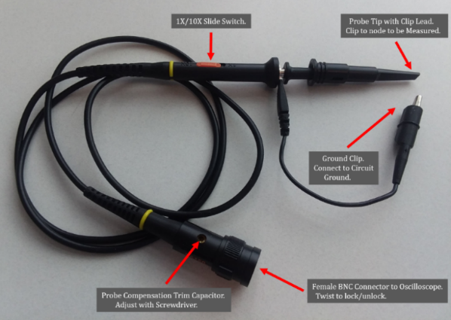Oscilloscopes measure and display voltage versus time, with the voltage on the y-axis and time on the x-axis. External probes are attached to oscilloscopes, with the probes connected to the circuit of interest. A typical 1X/10X Oscilloscope probe is shown in **Figure 8**, where a slide switch selects between a 1X and 10X probe.

**Figure 8**: 1X/10X Oscilloscope Probe.

A 10X oscilloscope probe attenuation is the most common setting for general purpose measurements. A 10X probe provides a 10 MΩ resistance/impedance to ground along with significantly reduced capacitance, compared to a 1X probe offering 1 MΩ resistance/impedance to ground and non-negligible capacitance. The result is that the 10X probe affects (loads) the circuit to be measured appreciably less than a 1X probe, which is important for medium and high-speed voltage measurements. **Figure 9** illustrates an equivalent circuit for a typical 10X oscilloscope probe and oscilloscope input.

The 10 MΩ resistance/impedance to ground for a 10X probe is formed by a 9 MΩ resistor in the probe connected in series with a 1 MΩ resistor to ground inside the oscilloscope, as illustrated in **Figure 9**. The 9 MΩ and 1 MΩ resistors form a 10:1 voltage divider, resulting in a factor of 10 attenuation. For medium and high-speed voltage measurements the reduced resistive and capacitive loading of a 10X probe is often more important than the loss of signal amplitude by a factor of 10. However, the 1X probe setting is beneficial when measuring small-amplitude low-frequency signals on an output with relatively low Thevenin output resistance. For a 1X probe the 9 MΩ series resistor illustrated in **Figure 9** is simply bypassed by means of a switch. Hence, a 1X oscilloscope probe provides an input impedance of only 1 MΩ, while a 10X probe provides a 10 MΩ input impedance (the same as a traditional DMM). Consequently, 1X probes provide a larger signal to be measured to the oscilloscope, whereas 10X probes provide a larger resistive load along with a smaller capacitive load to the circuit being measured.

**Figure 9**: Typical 10X Oscilloscope Probe Schematic.

For the circuit shown below in **Figure 10**, calculate the voltage Vmeas for both a 1X and then 10X oscilloscope probe utilized for the measurement, including your calculations below. Remember that a 1X probe simply bypasses the 9 MΩ resistor of the 10X probe, leaving only the 1 MΩ resistor inside the oscilloscope.

**Figure 10**: Thevenin Equivalent Circuit Measured with an Oscilloscope.

Vmeas_1X = 0.80 V (2 points.)

Vmeas_10X = 4.21 V (2 points.)

**Discussion and Conclusions Questions:** (For the following questions use your own words along with complete sentences. Points are to be deducted for AI generated answers.)

1. In your own words and using at least three complete sentences, explain how you can use individual rows of your **Table 1** data to arrive at the voltage drop across each of the 5 series resistors and confirm Kirchhoff’s Voltage Law. (3 points.)

Very simply, the values in Table 1 can be subtracted from each other sequentially to get the individual voltage values of the resistors. For example, if I wanted to find the voltage drop across resistor 4 at input voltage 5.0 V, I would use the voltage values: **N250mV =** 5V, **N5.0V =** 0.15V, **N50V** = 0.025V, **N250V** = 0.005V, and **N1000V** = 0.00125V. Resistor 4 corresponds with the node voltage **N250V.** That means that The voltage across resistors 4 and 5 together in series is 0.005V. Because the voltage across 5 is 0.00125V, these values can simply be subtracted to get the voltage across resistor 4. This would be 0.00375V.

1. In your own words and complete sentences, answer the following question. For a given input voltage applied to your voltage divider circuit of **Figure 7**, how would doubling the value of all five voltage divider resistors R1 through R5 affect the resulting node voltages N5.0V, N50V, N250V and N1000V, and why? (2 points.)

Doubling the value of all the five voltage divider resistors would not affect the voltages across the resistors. The reason for this is because all of the resistors were scaled at once. If one of the resistors was changed at a different scale than another, then the relative voltages would change. I proved this in LTSpice by doubling the resistance values and measuring the output voltages. They were the same as the original.

1. For the voltage divider circuit of **Figure 3**, Vout should equal 5 V when no additional resistance is connected across the a – b output terminals. Calculate the voltage Vout when a DMM with a 10 MΩ input impedance is connected across the a – b output terminals, showing at least two steps of your work below. (3 points.)

$$\frac{\left(10MΩ\right)\left(0.2MΩ\right)}{10MΩ+0.2MΩ}= 0.196MΩ$$

$$Vout=\frac{0.196MΩ}{1.8MΩ+0.196MΩ}*50V=4.91V$$

With a DMM connected: Vout = 4.91 V (3 points.)

1. The Digital Multimeter (DMM) block diagram of **Figure 5** includes an ADC with a ±200 mV Full-Scale Input Range. Using your own words with at least two complete sentences describe what an ADC is and does. (2 points.)

The ADC in a multimeter converts the analog input value to a digital output value to display to the screen. The digital output has a certain amount of bits for its range, so the analog is converted into the correct range inside the bits.

**LTspice Voltage Divider Lab Grading Rubric:** **This is a CAD lab to be done individually, rather than in teams, although please help each other out if/when opportunities arise, avoiding plagiarism. Submit an electronic version of a lab report to receive credit for doing this lab.** The goal of your **lab report is to provide sufficient documentation so that the lab can be repeated if necessary**. Therefore, simply add to this document to arrive at your lab report, as all of the explanatory text, procedures and Discussion and Conclusion questions contained in this document are required for a complete lab report. So for your lab report, **add a cover page, your results, along with your answers to the Discussion and Conclusions questions to the existing lab document**. Your answers to the **Discussion and Conclusions** questions are to **be uniquely yours** and not a copy of someone else’s answers to these questions. Your cover page is to include class, lab title, and author. The following rubric does not need to be included in your lab report.

|  |  |
| --- | --- |
| **Lab Report Item** | **Points** |
| Cover Page | 1 |
| **Part 1 – Voltage Dividers**  R2 Calculation. | 2 |
| **Part 2** – **DMM Voltage Measurements**  **Voltage Divider Resistor Equations** (8 points total, 2 points per included equation.)  **Figure 5** - (11 points total. 1 point for each correct resistor value (5 points), 1 point for each correct net name (5 points), 1 point for name included on schematic.)  **Table 1** - (10 points total. 0.4 points for each correct voltage value, -0.1 point for each missing unit.) | 29 |
| **Part 3 – Oscilloscope Probes**  Vmeas_1X and Vmeas_10X calculations (2 points each.) | 4 |
| Discussion and Conclusions | 10 |
| Grammar and Professionalism | 4 |
|  |  |
| **Total** | 50 |

Please give feedback on typos, etc. you find for this lab handout.

In step 2, it is NOT clear that: $V\text{in_full-scale }\text{≠ }V\text{in}$

A lot of students, including me, got caught up on that. It looks like all of the b values are supposed to be the same because Vin_full_scale is the same for all the bs.